Steps to Complete the Task Successfully

Step 1: Access Jenkins UI
- Click on the Jenkins button available on the top bar.
- Log in to Jenkins using the following credentials:
  - Username: admin
  - Password: Adm1n321
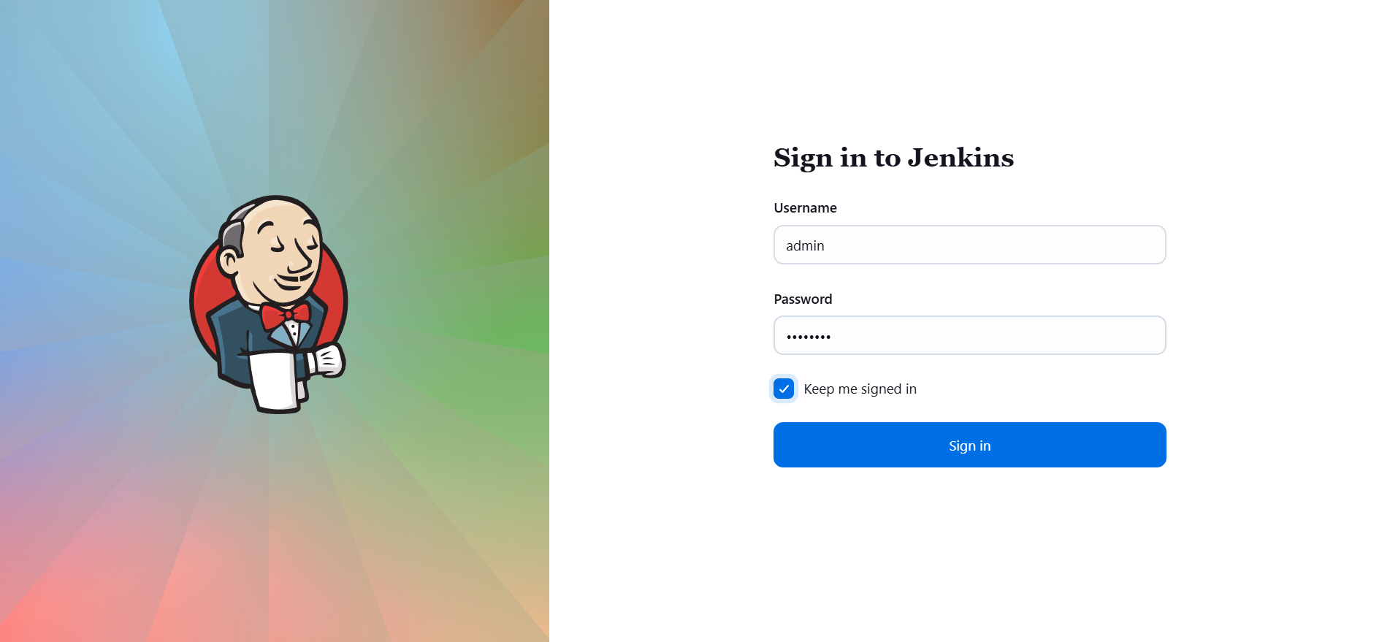

Step 2: Create a New Jenkins Job
- From the Jenkins dashboard, click New Item.
- Enter the job name as:
- parameterized-job
- Select Freestyle project.
- Click OK to create the job.
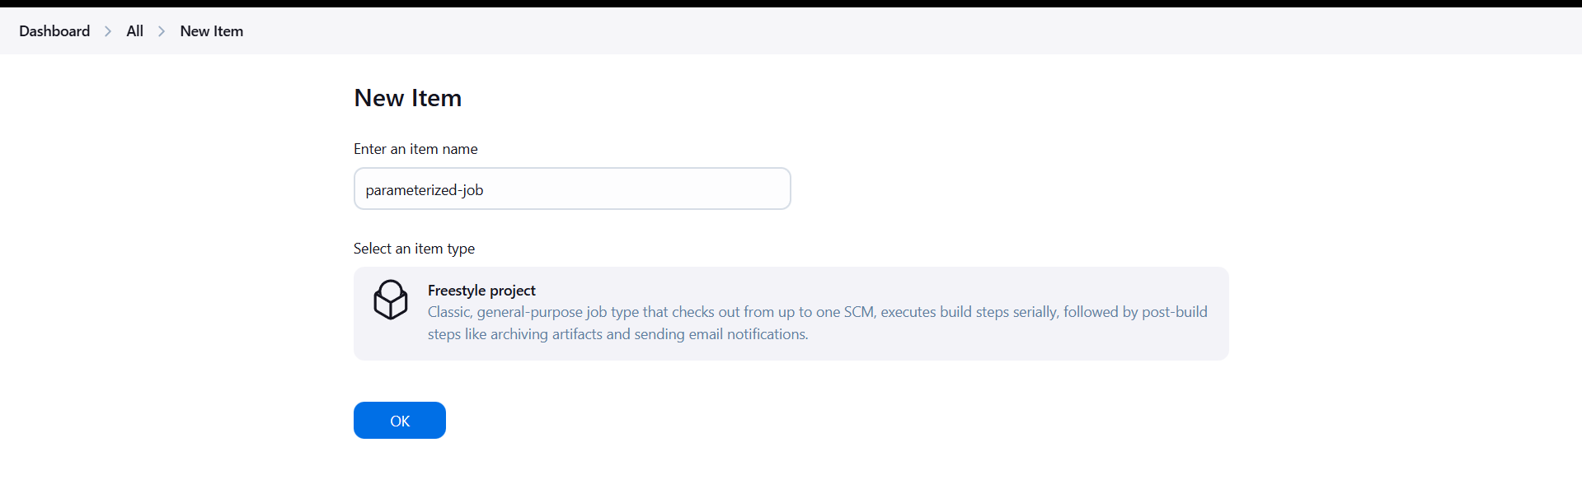

Step 3: Enable Parameterized Build
- In the job configuration page, check This project is parameterized.
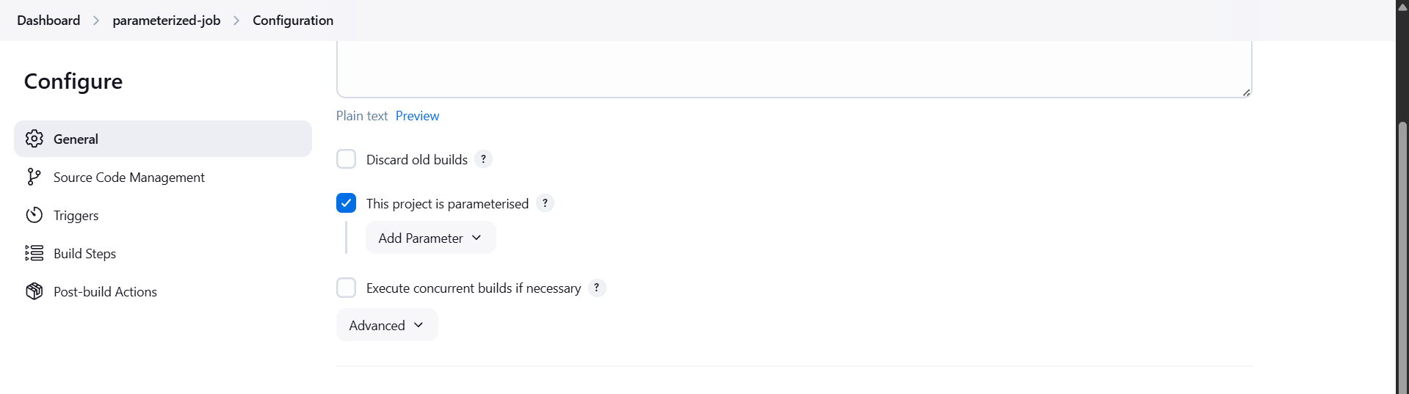

Step 4: Add String Parameter
- Click Add Parameter → String Parameter.
- Configure the parameter as follows:
  - Name: Stage
  - Default Value: Build
- Save the parameter.
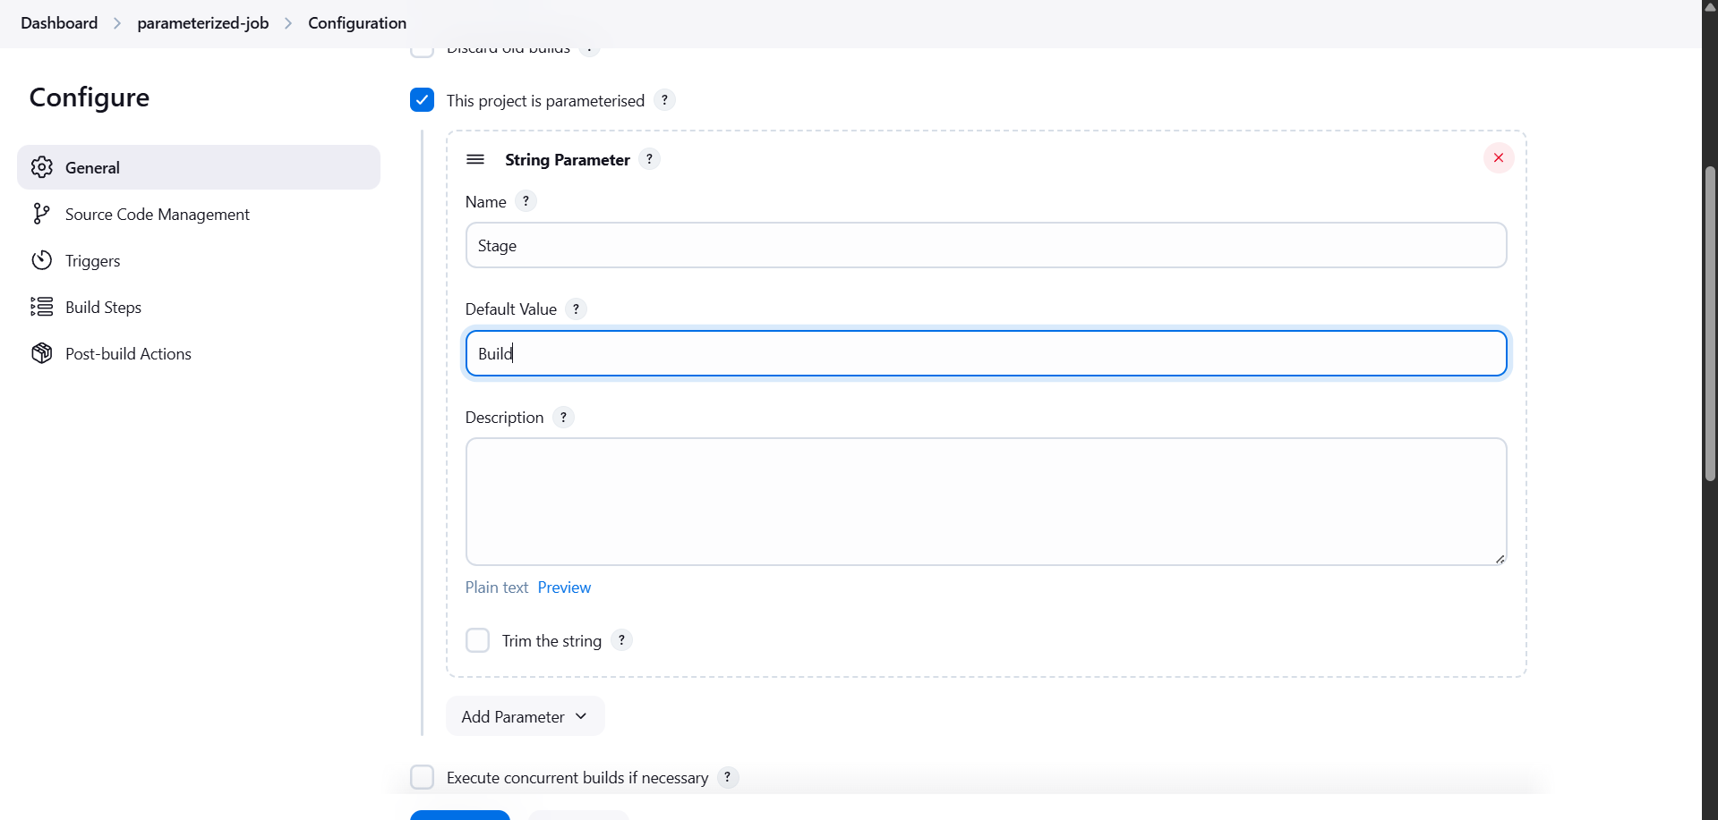

Step 5: Add Choice Parameter
- Click Add Parameter → Choice Parameter.
- Configure the parameter as follows:
  - Name: env
  - Choices:
  - Development
  - Staging
  - Production
- Save the parameter.
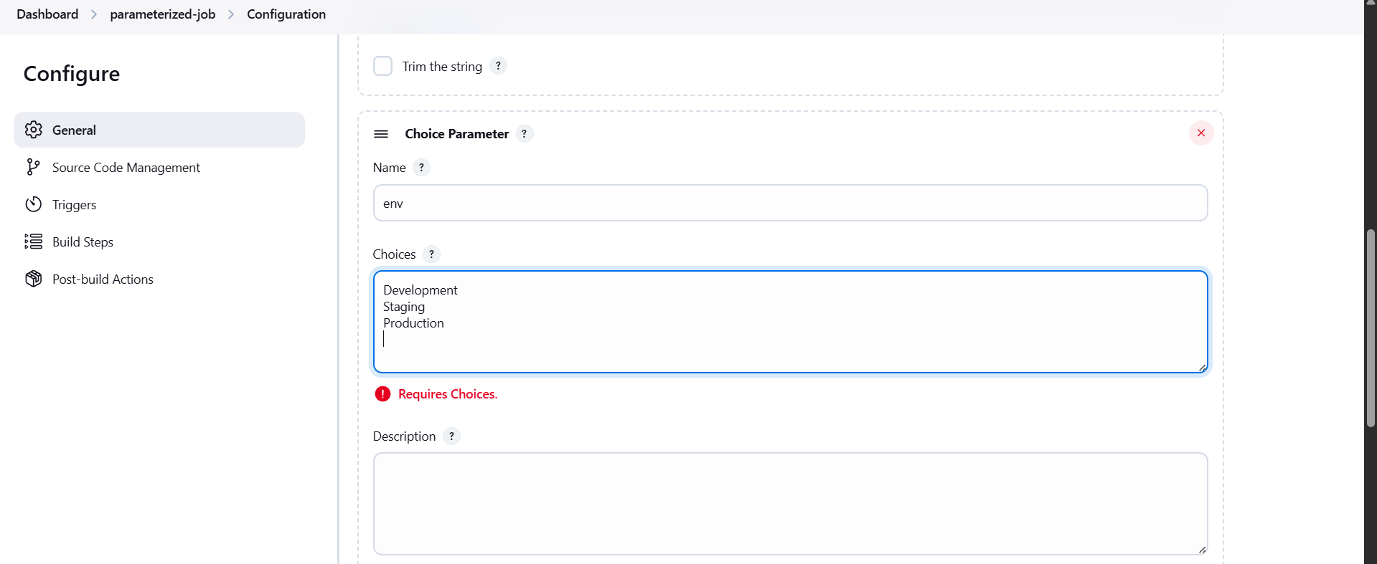

Step 6: Configure Build Step
- Scroll to the Build section.
- Click Add build step → Execute shell.
- Enter the following command:
- echo "Stage: $Stage"
- echo "Environment: $env"
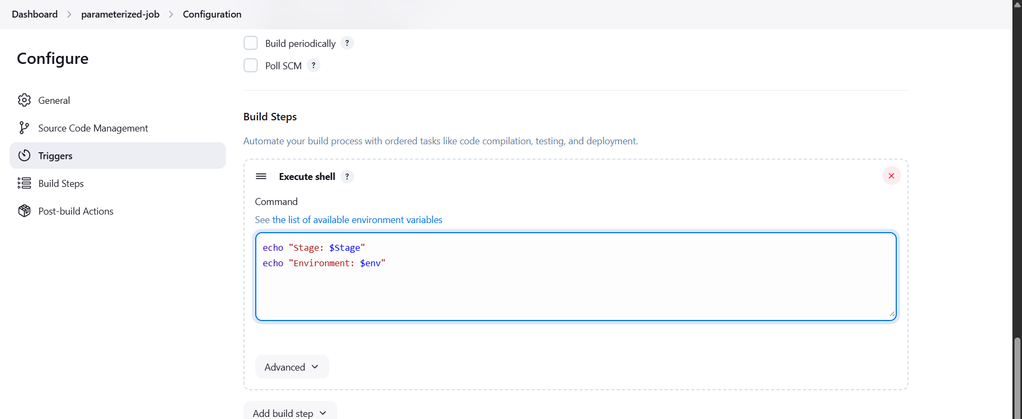

Step 7: Save the Job
- Click Save to apply all configurations.

Step 8: Build the Job with Parameters
- Click Build with Parameters.
- Select the following values:
  - Stage: Build (default)
  - env: Development
- Click Build.
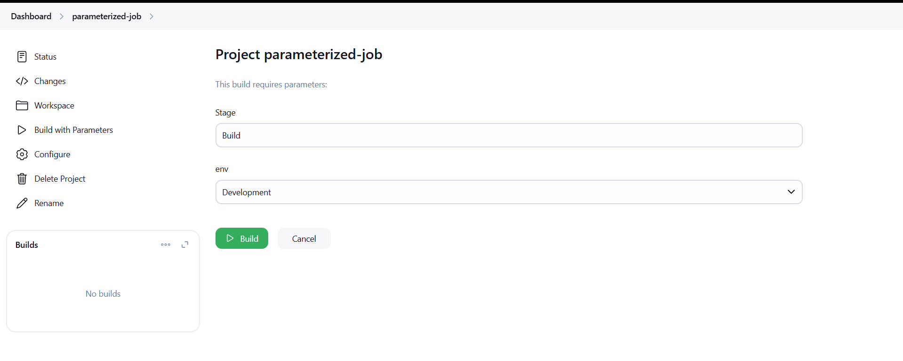

Step 9: Verify the Build
- Open the completed build.
- Check Console Output.
- Confirm that both parameter values are printed correctly and the build completes successfully.
